PROJECT 2

Avishek Mukherjee

E-mail ID: amukherjee3@albany.edu

## Tools used:

Python 2.7

Shell Script

Text Files

SSH (Terminus)

Microsoft VS Code

GREP

EGREP (extended grep for OR condition)

AWK

SED

Perl (for regexp to regexp extraction)

# Introduction

Why is route stability important?

Ans: The main goal of the internet-architecture is that large-scale routing changes should occur rarely, but that cannot ignore the fact that the internet is unpredictable in nature.

The factors affected by routing stability: [Refer to PAXSON 7.1]

1. Degree to which the properties of network path are predictable
2. The degree to which the connection can learn about the network conditions based on observations of path conditions
3. The degree to which real-time protocols must be prepared to recreate or migrate router states
4. Stability can lead to hard-coding of paths.

# Methodology

1. Make a python script to scout the working links
2. Test the working links for compatibility
3. Make a Python file to ping and collect the statistics
4. Store the STDOUT to a text file
5. Run the Python script in a loop using the NPD.SH file (analogous to the network probes daemon)
6. After you are done collecting the data, download the file to respective directories and clean using the below commands.

Downloading data from the CSI 516 virtual machine to the local drive

Go to the virtual machine and get the list of directory

drwx--S--- 2 am636787 colord 512 Nov 11 20:21 boston

drwx--S--- 2 am636787 colord 512 Nov 11 20:20 brazil

drwx--S--- 2 am636787 colord 512 Nov 11 20:21 calpoly

drwx--S--- 2 am636787 colord 512 Nov 19 12:21 client

drwx--S--- 2 am636787 colord 512 Nov 11 20:27 monash

drwx--S--- 2 am636787 colord 512 Nov 11 20:20 montana

drwx--S--- 2 am636787 colord 512 Nov 11 20:20 oregon

drwx--S--- 2 am636787 colord 512 Nov 11 20:20 russia

drwx--S--- 2 am636787 colord 512 Nov 11 20:20 rutgers

drwx--S--- 2 am636787 colord 512 Nov 11 20:20 sjtu

drwx--S--- 2 am636787 colord 512 Nov 9 21:17 .ssh

drwx--S--- 2 am636787 colord 512 Nov 26 19:41 wash1

drwx--S--- 2 am636787 colord 512 Nov 11 20:20 wash4

drwx--S--- 2 am636787 colord 512 Nov 11 20:21 wisc

scp [am636787@csi516-fa18.arcc.albany.edu](mailto:am636787@csi516-fa18.arcc.albany.edu):/home1/s/a/am636787/sjtu/newfile.txt /Users/ovishake/Documents/china

## Nodes scouted by me for use:

pl1.eng.monash.edu.au

planetlab-2.sjtu.edu.cn

planetlab01.cs.washington.edu

planetlab1.pop-pa.rnp.br

planetlab04.cs.washington.edu

planetlab3.cs.uoregon.edu

pl2.cs.montana.edu

planetlab1.rutgers.edu

plab1.cs.msu.ru

planetlab3.wail.wisc.edu

planetlab-2.calpoly-netlab.net

planetlab-01.bu.edu

## Hostname used:

planetlab01.cs.washington.edu —> pl1.eng.monash.edu.au

planetlab01.cs.washington.edu —> plab1.cs.msu.ru

planetlab3.cs.uoregon.edu —> planetlab01.cs.washington.edu

planetlab-2.sjtu.edu.cn —> plab1.cs.msu.ru

planetlab1.pop-pa.rnp.br —> planetlab-2.sjtu.edu.cn

planetlab3.cs.uoregon.edu —> planetlab01.cs.washington.edu

## Python Script to get the ping statistics and the traceroute:

import subprocess

#read the server names

hostfile = open('servername.txt','r')

#list for holding the servers

listofserver = []

for lines in hostfile:

ph = lines.rstrip()

#removes the new line character at the end

listofserver.append(ph)

#append to myfile

myfile = open('newfile.txt',"a+")

n = len(listofserver)

timestamp = subprocess.Popen(["date"],stdout=subprocess.PIPE).communicate()[0]

myfile.writelines(timestamp)

for i in range(n):

pingout = subprocess.Popen(["ping","-c","20", listofserver[i]], stdout= subprocess.PIPE).communicate()[0]

traceroute = subprocess.Popen(["traceroute",listofserver[i]], stdout=subprocess.PIPE).communicate()[0]

myfile.writelines(pingout)

myfile.writelines(traceroute)

myfile.close()

hostfile.close()

All the output was loaded into a file called as ‘newfile.txt’

## Downloading the files:

1. scp /home/albany_ccn2/ovi/newfile.txt [am636787@csi516-fa18.arcc.albany.edu:/home1/s/a/am636787/folder](mailto:am636787@csi516-fa18.arcc.albany.edu:/home1/s/a/am636787/folder) (change the folder to download it into a folder of your choice)
2. scp [am636787@csi516-fa18.arcc.albany.edu](mailto:am636787@csi516-fa18.arcc.albany.edu):/home1/s/a/am636787/monash/newfile.txt /Users/ovishake/Documents/monash
3. Clean the VM periodically to avoid running into write-error (because of disk quotas)

## Cleaning the data for node specific RTT(latency)

1. egrep -B1 'traceroute to pl1.eng.monash.edu.au' newfile.txt | awk '{print $4}' > washington2australia.txt
2. sed '/^$/d' washington2australia.txt > temp.txt
3. sed '/(130.194.252.8),/d' temp.txt > wash2aus.txt
4. Open the file in VSCODE
5. Find and replace all the ‘/’
6. Save the file as a CSV

### Sample of the resulting file:

159.122/159.251/159.318/0.383

159.099/159.261/159.327/0.338

159.084/159.236/159.341/0.366

159.066/159.236/159.303/0.362

159.075/159.280/160.214/0.286

159.054/159.199/159.295/0.555

159.099/159.340/161.426/0.483

159.059/159.223/159.353/0.494

159.109/159.242/159.304/0.288

159.129/159.250/159.375/0.493

159.055/159.248/159.313/0.555

159.135/159.281/159.351/0.507

## Getting the ploss

1. egrep -B3 'traceroute to pl1.eng.monash.edu.au' newfile.txt | grep 'packet loss' > plossOFwash2aus.csv
2. VSCODE find and replace ‘% packet loss’ with a blank
3. File becomes readable for Excel
4. In Excel ,select the packet loss column’, go to ‘Conditional Formatting’ 🡪 Highlight Cells Rules 🡪 Greater than 0 and then apply the rule.

### Sample Output of Packet Loss formatting for Washington to Australia:



## Extracting Trace of a Node:

1. perl -ne 'print if /traceroute to planetlab04.cs.washington.edu/../PING/' newfile.txt
2. sed '/PING/d' traceAUStoWash.txt > cleanAUStoWash.txt
3. place all the files in a consolidated folder.

### Examples

Washington 🡪 Australia

Number of Hops: 15

xe-5-0-6-211.pe1.nbpk.vic.aarnet.net.au (138.44.64.221) faced certain outages as probes were lost and it gave a ***

Australia 🡪 Washington

Number of Hops: 15

Detecting Outages:

awk '{if($1 > 15){print $0}}' cleanAUStoWash.txt

If the output contains lines with the number 30 and still doesn’t reach the router then it’s a problem.

COUTING THE NUMBER OF HOPS BETWEEN PINGS

awk '!/traceroute to/{count++}/traceroute to/{print count; count = 0}' FILENAME.TXT

## Analysis

How often did you detect outages in pair-wise paths between your nodes (present this as a fraction of all monitored paths)? a. How many of them were temporary (as defined in section 6.7. from [Paxson96])? For each failure, can you determine the likely cause based on your measurements? If yes, what is it? If not, what additional information do you need to answer this question? b. How many failures were long-term outages? Can you determine the root-cause for these failures? (remember that PlanetLab nodes go down for repairs often).

pl1.eng.monash.edu.au 🡪 planetlab-2.sjtu.edu.cn

temporary outage: very frequent, all the routes had a *

how to detect: * in traceroute

permanent outages: 2 occurrences OUT OF 332 observations

methodology: awk '{if($1 > 29){print $0}}' cleanAUS2CHN.TXT

temporary outages: all times, excluding the permanent outages

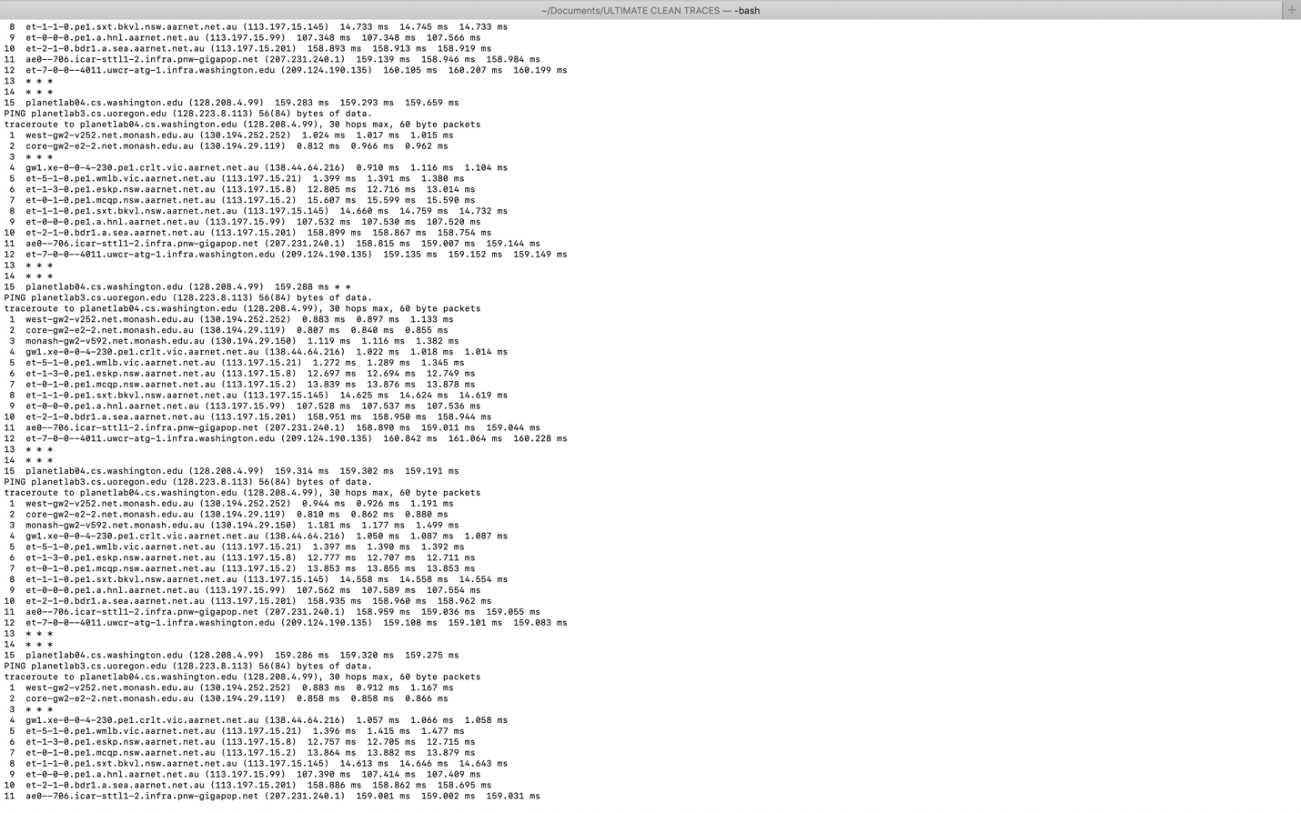

Outages:

|  |  |  |  |
| --- | --- | --- | --- |
| Node 1 | Node 2 | Temporary | Permanent |
| pl1.eng.monash.edu.au | planetlab04.cs.washington.edu | 330 | 0 (Frac: 0) |
| planetlab04.cs.washington.edu | pl1.eng.monash.edu.au | 308 | 0 (Frac: 0) |
| planetlab1.pop-pa.rnp.br | planetlab04.cs.washington.edu | 77 | 0 (Frac: 0) |
| planetlab04.cs.washington.edu | planetlab1.pop-pa.rnp.br | 308 | 0 (Frac: 0) |
| planetlab-2.sjtu.edu.cn | plab1.cs.msu.ru | 288 | 16 (Frac: 0.050 |
| plab1.cs.msu.ru | planetlab-2.sjtu.edu.cn | 330 | 2 (Frac: 0.006) |
| planetlab04.cs.washington.edu | plab1.cs.msu.ru | 308 | 1 (Frac: 0.003) |
| plab1.cs.msu.ru | planetlab04.cs.washington.edu | 330 | 0 (Frac: 0) |
| planetlab-2.sjtu.edu.cn | pl1.eng.monash.edu.au | 305 | 0 (Frac: 0) |
| pl1.eng.monash.edu.au | planetlab-2.sjtu.edu.cn | 330 | 2 (Frac: 0.006) |

China to Russia had significant number of permanent outages detected using the below method:

1. awk '{if($1 > 29){print $0}}' cleanCHINA2RUSSIA.TXT | awk '!/188.44.50.106/' | wc -l

## Example:

dyn-169-226-64-132:ULTIMATE CLEAN TRACES ovishake$ awk '{if($1 > 29){print $0}}' cleanCHINA2RUSSIA.TXT | awk '!/188.44.50.106/'

30 93.180.0.191 (93.180.0.191) 385.344 ms 387.124 ms 386.924 ms

30 93.180.0.191 (93.180.0.191) 479.181 ms 478.981 ms 477.977 ms

30 ndn-gw2.runnet.ru (109.105.102.58) 386.870 ms 387.088 ms 394.251 ms

30 msu.msk.runnet.ru (194.190.254.118) 452.141 ms 455.779 ms 452.940 ms

30 spb-bm18-1-gw.runnet.ru (185.141.124.140) 467.241 ms 469.484 ms 465.919 ms

30 msu.msk.runnet.ru (194.190.254.118) 471.904 ms 420.410 ms 401.366 ms

30 msk-m9-1-gw.runnet.ru (185.141.124.144) 475.226 ms 475.044 ms 475.071 ms

30 msk-m9-1-gw.runnet.ru (185.141.124.144) 416.197 ms 417.396 ms 416.351 ms

30 ndn-gw2.runnet.ru (109.105.102.58) 441.209 ms 399.908 ms 399.166 ms

30 ndn-gw2.runnet.ru (109.105.102.58) 419.574 ms 419.914 ms 420.555 ms

30 ndn-gw2.runnet.ru (109.105.102.58) 439.315 ms 437.073 ms 437.105 ms

30 ndn-gw2.runnet.ru (109.105.102.58) 481.520 ms 483.212 ms 486.433 ms

30 ndn-gw2.runnet.ru (109.105.102.58) 497.492 ms 483.501 ms 501.285 ms

30 ndn-gw2.runnet.ru (109.105.102.58) 386.526 ms 386.438 ms 386.517 ms

30 msu.msk.runnet.ru (194.190.254.118) 444.567 ms 417.442 ms 415.848 ms

30 msu.msk.runnet.ru (194.190.254.118) 411.187 ms 418.977 ms 420.431 ms

### An example of permanent outages:

traceroute to plab1.cs.msu.ru (188.44.50.106), 30 hops max, 60 byte packets

1 acar-atg-02-vlan77.cac.washington.edu (128.208.4.102) 2.705 ms 2.379 ms 2.364 ms

2 lo0--1.uwcr-atg-1.infra.washington.edu (198.48.66.1) 0.912 ms 0.921 ms 1.009 ms

3 10.132.1.75 (10.132.1.75) 0.476 ms 0.485 ms 0.546 ms

4 ae0--4012.icar-sttl1-2.infra.pnw-gigapop.net (209.124.181.134) 0.579 ms 0.568 ms 0.573 ms

5 et-4-3-0.1220.rtsw.seat.net.internet2.edu (64.57.28.53) 0.721 ms 0.695 ms 0.690 ms

6 et-4-0-0.4079.rtsw.miss2.net.internet2.edu (162.252.70.0) 11.436 ms 11.370 ms 11.391 ms

7 et-4-0-0.4079.rtsw.minn.net.internet2.edu (162.252.70.58) 34.749 ms 34.609 ms 34.690 ms

8 et-1-1-2.4079.rtsw.eqch.net.internet2.edu (162.252.70.106) 42.755 ms 42.802 ms 42.782 ms

9 ae-1.4079.rtsw.clev.net.internet2.edu (162.252.70.130) 51.333 ms 51.236 ms 51.390 ms

10 et-2-0-0.4079.rtsw.ashb.net.internet2.edu (162.252.70.54) 58.841 ms 58.869 ms 58.938 ms

11 ae-2.4079.rtsw.wash.net.internet2.edu (162.252.70.136) 59.293 ms 59.230 ms 59.328 ms

12 ae-5.4079.rtsw.newy32aoa.net.internet2.edu (162.252.70.139) 64.267 ms 64.143 ms 64.183 ms

13 us-man.nordu.net (109.105.98.9) 64.215 ms 64.394 ms 64.434 ms

14 nl-sar.nordu.net (109.105.97.65) 150.131 ms 150.071 ms 150.172 ms

15 de-hmb.nordu.net (109.105.97.50) 156.425 ms 156.283 ms 156.530 ms

16 fi-csc2.nordu.net (109.105.97.76) 173.632 ms 172.775 ms 174.378 ms

17 ndn-gw2.runnet.ru (109.105.102.58) 183.377 ms 183.558 ms 183.373 ms

18 spb-bm18-1-gw.runnet.ru (185.141.124.140) 187.408 ms 187.150 ms 186.685 ms

19 * * *

20 * * *

21 * * *

22 * * *

23 * * *

24 * * *

25 * * *

26 * * *

27 * * *

28 * * *

29 * * *

30 * * *

### Conclusion:

Based on the above observations:

1. Most permanent outages are at the edges
2. At the core the outages are temporary in nature
3. In case of outages, (which may be a server configured not to respond to ICMP messages)
4. Most of the nodes were fairly stable other than the CHINA🡪RUSSIA.

3. Of the failures you detected, what percentage are in the core vs. in the edge (local ISP failures)?

ANS: Refer to the permanent outages, if there was outage in the core the packets took a detour, that resulted in standard deviation in the PING times. All temporary outages were at the core.

Permanent outages were at the edge and is represented by the FRAC in the above table ranging in values from 0 to 5.5%. With the median value being 0%.

4. Did you detect any significant differences in the reliability of continental links (e.g. US<- >US, US<->Canada) vs inter-continental links crossing the Atlantic or the Pacific Ocean?

Ans:

Refer to the below image of planetlab04.cs.washington.edu -- pl1.eng.monash.edu.au

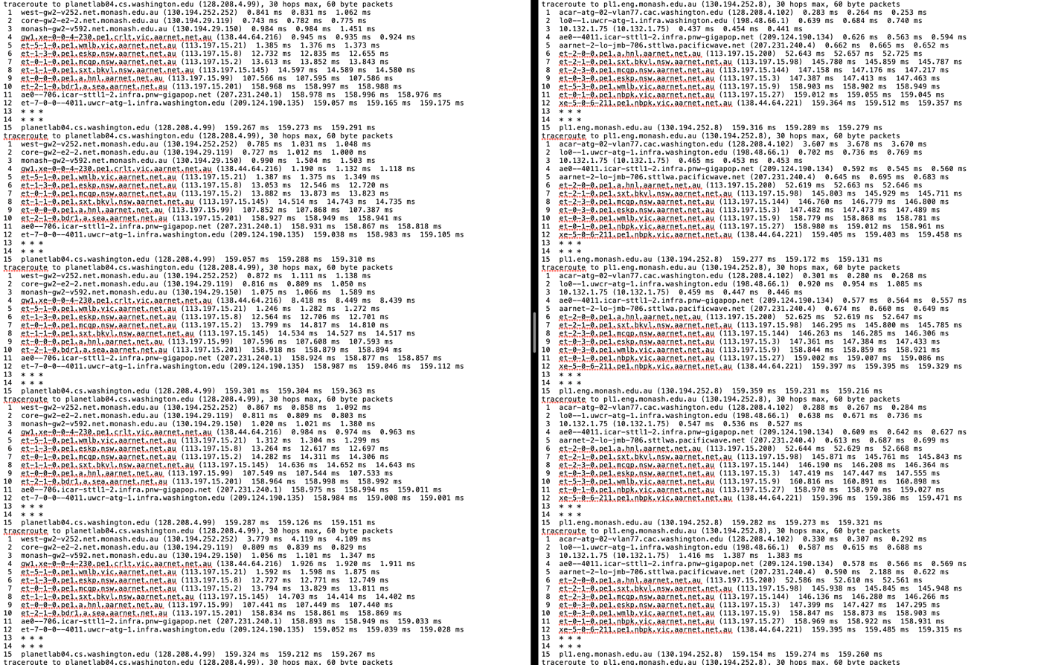

On inspection I found that the routes were fairly stable at 15 HOPS with some tours taking 16 to 18 HOPS. There were instances of lost probes just as they were about to reach their destinations.

INTRA-CONTINENTAL ROUTING

[planetlab3.cs.uoregon.edu](http://planetlab3.cs.uoregon.edu) to planetlab04.cs.washington.edu

differences: with inter-continental routing through the trans-atlantic:

1. Lesser number of hops
2. Lesser travelling time
3. Number of HOPS were fairly constant at 12
4. See below that the number of HOPS required is at max 13, and the route is fairly stable.

dyn-169-226-64-132:ULTIMATE CLEAN TRACES ovishake$ awk '{if($1 > 12){print $0}}' cleanOREGON2WASHINGTON.TXT | awk '!/traceroute/'

13 planetlab04.cs.washington.edu (128.208.4.99) 18.194 ms 18.549 ms *

13 planetlab04.cs.washington.edu (128.208.4.99) 18.116 ms 18.100 ms 18.103 ms

13 planetlab04.cs.washington.edu (128.208.4.99) 18.147 ms 18.160 ms 18.066 ms

13 planetlab04.cs.washington.edu (128.208.4.99) 18.337 ms 18.122 ms *

13 planetlab04.cs.washington.edu (128.208.4.99) 18.175 ms 18.080 ms 18.097 ms

13 planetlab04.cs.washington.edu (128.208.4.99) 18.103 ms 18.094 ms 18.136 ms

13 planetlab04.cs.washington.edu (128.208.4.99) 18.133 ms 18.090 ms *

13 planetlab04.cs.washington.edu (128.208.4.99) 18.105 ms 18.169 ms 18.249 ms

13 planetlab04.cs.washington.edu (128.208.4.99) 18.415 ms 18.169 ms 18.095 ms

13 planetlab04.cs.washington.edu (128.208.4.99) 18.089 ms * *

13 planetlab04.cs.washington.edu (128.208.4.99) 18.138 ms 18.138 ms 18.569 ms

dyn-169-226-64-132:ULTIMATE CLEAN TRACES ovishake$

5. Did you detect any route fluttering (as defined in section 6.4 from [Paxson96])? Where and how often?

Ans: Yes, there were many fluttering, see the below text for the text in RED. The text is extracted from the probes sent from There is fluttering but the fluttering is **non-harmful** as they were within the same subnet.

WHERE? Mainly at : **planetlab01.cs.washington.edu 🡪 planetlab3.cs.uoregon.edu.** I selected this node specifically to capture the fluttering. See the long lines.

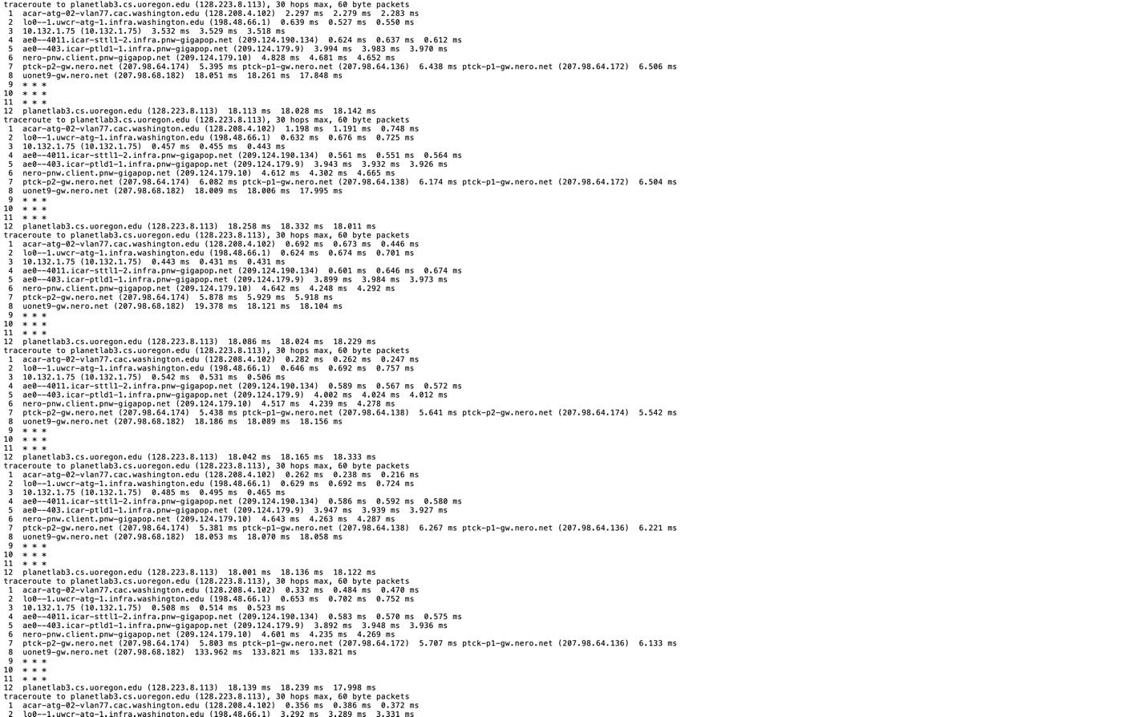

--- planetlab3.cs.uoregon.edu ping statistics ---

20 packets transmitted, 20 received, 0% packet loss, time 19017ms

rtt min/avg/max/mdev = 18.092/18.191/18.821/0.247 ms

traceroute to planetlab3.cs.uoregon.edu (128.223.8.113), 30 hops max, 60 byte packets

1 acar-atg-02-vlan77.cac.washington.edu (128.208.4.102) 2.220 ms 2.198 ms 2.186 ms

2 lo0--1.uwcr-atg-1.infra.washington.edu (198.48.66.1) 0.606 ms 0.619 ms 0.667 ms

3 10.132.1.75 (10.132.1.75) 0.479 ms 0.451 ms 0.454 ms

4 ae0--4011.icar-sttl1-2.infra.pnw-gigapop.net (209.124.190.134) 0.578 ms 0.564 ms 0.563 ms

5 ae0--403.icar-ptld1-1.infra.pnw-gigapop.net (209.124.179.9) 3.922 ms 3.942 ms 3.929 ms

6 nero-pnw.client.pnw-gigapop.net (209.124.179.10) 4.933 ms 4.554 ms 4.581 ms

7 ptck-p2-gw.nero.net (207.98.64.174) 5.851 ms ptck-p1-gw.nero.net (207.98.64.138) 5.851 ms 5.839 ms

8 uonet9-gw.nero.net (207.98.68.182) 17.933 ms 18.264 ms 17.881 ms

9 * * *

10 * * *

11 * * *

12 planetlab3.cs.uoregon.edu (128.223.8.113) 18.017 ms 18.372 ms 18.336 ms

--- planetlab3.cs.uoregon.edu ping statistics ---

20 packets transmitted, 20 received, 0% packet loss, time 19018ms

rtt min/avg/max/mdev = 18.117/18.291/19.033/0.281 ms

traceroute to planetlab3.cs.uoregon.edu (128.223.8.113), 30 hops max, 60 byte packets

1 acar-atg-02-vlan77.cac.washington.edu (128.208.4.102) 1.155 ms 1.131 ms 1.117 ms

2 lo0--1.uwcr-atg-1.infra.washington.edu (198.48.66.1) 0.586 ms 0.615 ms 0.856 ms

3 10.132.1.75 (10.132.1.75) 0.427 ms 0.451 ms 0.439 ms

4 ae0--4011.icar-sttl1-2.infra.pnw-gigapop.net (209.124.190.134) 0.793 ms 0.704 ms 0.689 ms

5 ae0--403.icar-ptld1-1.infra.pnw-gigapop.net (209.124.179.9) 3.981 ms 4.057 ms 4.045 ms

6 nero-pnw.client.pnw-gigapop.net (209.124.179.10) 4.943 ms 5.178 ms 5.182 ms

7 ptck-p1-gw.nero.net (207.98.64.138) 6.213 ms ptck-p1-gw.nero.net (207.98.64.172) 5.775 ms ptck-p1-gw.nero.net (207.98.64.136) 5.772 ms

8 uonet9-gw.nero.net (207.98.68.182) 75.261 ms 75.327 ms 75.317 ms

9 * * *

10 * * *

11 * * *

12 planetlab3.cs.uoregon.edu (128.223.8.113) 18.155 ms 18.130 ms 18.018 ms

Suprisingly the transatlantic link to [plab1.cs.msu.ru](http://plab1.cs.msu.ru) showed much less fluttering compared to the Oregon.

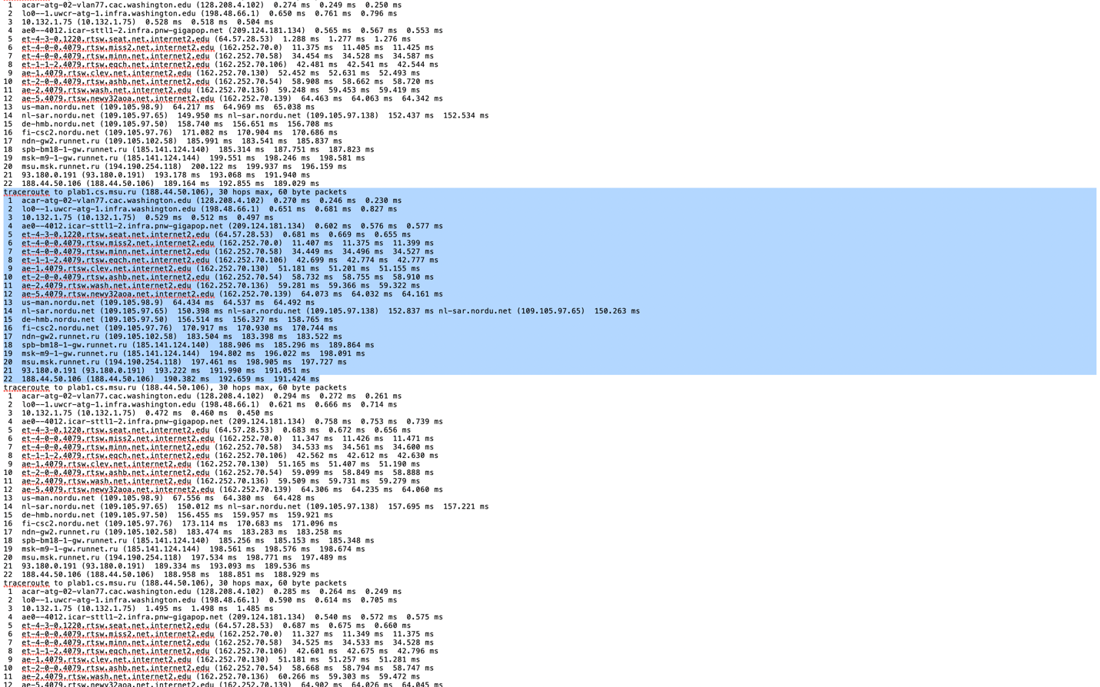

Another problematic route with all kinds of fluttering plab1.cs.msu.ru 🡪 planetlab-2.sjtu.edu.cn

Ans: 1 west-gw2-v252.net.monash.edu.au (130.194.252.252) 0.798 ms 1.077 ms 1.598 ms

2 core-gw2-e2-2.net.monash.edu.au (130.194.29.119) 0.732 ms 0.981 ms 0.999 ms

3 monash-gw2-v592.net.monash.edu.au (130.194.29.150) 0.971 ms 0.972 ms 1.209 ms

4 gw1.xe-0-0-4-230.pe1.crlt.vic.aarnet.net.au (138.44.64.216) 0.928 ms 0.930 ms 0.919 ms

5 et-5-1-0.pe1.wmlb.vic.aarnet.net.au (113.197.15.21) 1.197 ms 1.402 ms 1.403 ms

6 et-1-3-0.pe1.eskp.nsw.aarnet.net.au (113.197.15.8) 12.771 ms 12.535 ms 12.675 ms

7 xe-0-1-0.pe1.rsby.nsw.aarnet.net.au (113.197.15.198) 13.592 ms et-0-1-0.pe1.mcqp.nsw.aarnet.net.au (113.197.15.2) 13.618 ms xe-0-1-0.pe1.rsby.nsw.aarnet.net.au (113.197.15.198) 13.595 ms

8 et-5-1-0.pe1.brwy.nsw.aarnet.net.au (113.197.15.5) 14.200 ms et-7-1-0.pe1.brwy.nsw.aarnet.net.au (113.197.15.13) 13.818 ms et-5-1-0.pe1.brwy.nsw.aarnet.net.au (113.197.15.5) 14.183 ms

9 xe-1-2-0.bdr1.a.sin.aarnet.net.au (113.197.15.207) 152.811 ms 152.754 ms 152.745 ms

10 202.179.249.61 (202.179.249.61) 152.663 ms 152.694 ms 152.687 ms

11 202.179.241.101 (202.179.241.101) 185.388 ms 184.941 ms 185.267 ms

12 202.179.241.1 (202.179.241.1) 223.228 ms 223.146 ms 223.219 ms

13 202.179.241.10 (202.179.241.10) 229.008 ms 228.990 ms 228.938 ms

14 210.25.187.45 (210.25.187.45) 224.373 ms 223.884 ms 223.893 ms

15 210.25.189.69 (210.25.189.69) 224.319 ms 224.345 ms 224.337 ms

16 101.4.114.173 (101.4.114.173) 223.751 ms 226.012 ms 223.822 ms

17 * 101.4.115.173 (101.4.115.173) 250.242 ms 251.313 ms

18 * * *

19 * * *

20 * * *

21 planetlab-2.sjtu.edu.cn (202.112.28.100) 249.288 ms 248.956 ms 249.323 ms

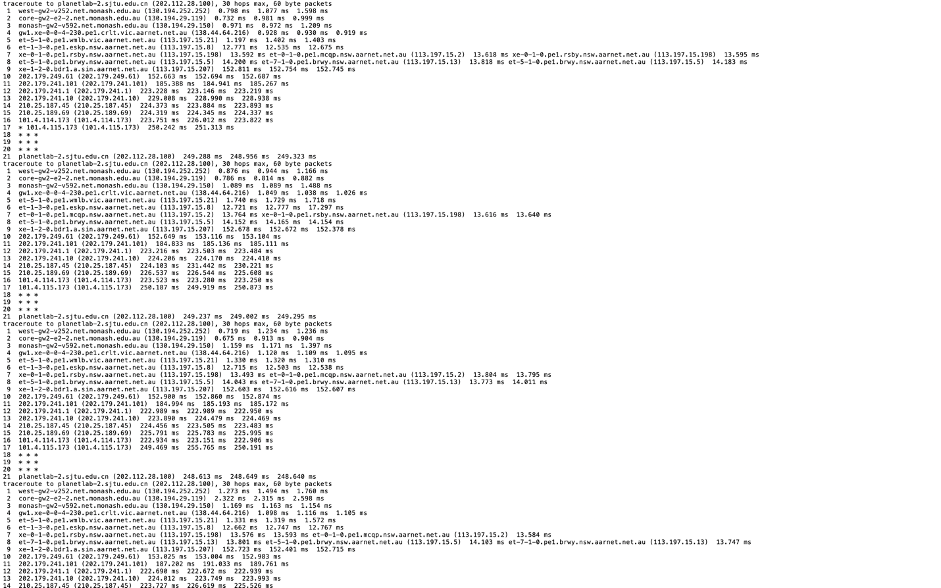

6. Did you see any inconsistencies (in terms of hop count and geographical location) between the forward (A🡪B) and reverse (B🡪A) path in your pair-wise measurements?

Ans: plab1.cs.msu.ru 🡪 planetlab-2.sjtu.edu.cn

This route showed a lot of inconsistencies, including fluttering, geographical inconsistencies, mismatch in hopcount. As in A🡪B is not equal to B🡪 A. Please see the highlighted zone to see the inconsistency in hop count.

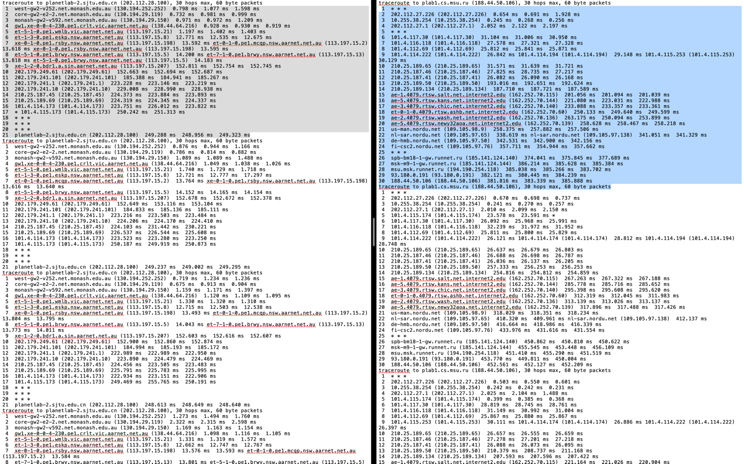

plab1.cs.msu.ru 🡪 planetlab-2.sjtu.edu.cn went through Australia.

1 west-gw2-v252.net.monash.edu.au (130.194.252.252) 0.798 ms 1.077 ms 1.598 ms

2 core-gw2-e2-2.net.monash.edu.au (130.194.29.119) 0.732 ms 0.981 ms 0.999 ms

3 monash-gw2-v592.net.monash.edu.au (130.194.29.150) 0.971 ms 0.972 ms 1.209 ms

4 gw1.xe-0-0-4-230.pe1.crlt.vic.aarnet.net.au (138.44.64.216) 0.928 ms 0.930 ms 0.919 ms

5 et-5-1-0.pe1.wmlb.vic.aarnet.net.au (113.197.15.21) 1.197 ms 1.402 ms 1.403 ms

6 et-1-3-0.pe1.eskp.nsw.aarnet.net.au (113.197.15.8) 12.771 ms 12.535 ms 12.675 ms

7 xe-0-1-0.pe1.rsby.nsw.aarnet.net.au (113.197.15.198) 13.592 ms et-0-1-0.pe1.mcqp.nsw.aarnet.net.au (113.197.15.2) 13.618 ms xe-0-1-0.pe1.rsby.nsw.aarnet.net.au (113.197.15.198) 13.595 ms

8 et-5-1-0.pe1.brwy.nsw.aarnet.net.au (113.197.15.5) 14.200 ms et-7-1-0.pe1.brwy.nsw.aarnet.net.au (113.197.15.13) 13.818 ms et-5-1-0.pe1.brwy.nsw.aarnet.net.au (113.197.15.5) 14.183 ms

9 xe-1-2-0.bdr1.a.sin.aarnet.net.au (113.197.15.207) 152.811 ms 152.754 ms 152.745 ms

10 202.179.249.61 (202.179.249.61) 152.663 ms 152.694 ms 152.687 ms

11 202.179.241.101 (202.179.241.101) 185.388 ms 184.941 ms 185.267 ms

12 202.179.241.1 (202.179.241.1) 223.228 ms 223.146 ms 223.219 ms

13 202.179.241.10 (202.179.241.10) 229.008 ms 228.990 ms 228.938 ms

14 210.25.187.45 (210.25.187.45) 224.373 ms 223.884 ms 223.893 ms

15 210.25.189.69 (210.25.189.69) 224.319 ms 224.345 ms 224.337 ms

16 101.4.114.173 (101.4.114.173) 223.751 ms 226.012 ms 223.822 ms

17 * 101.4.115.173 (101.4.115.173) 250.242 ms 251.313 ms

18 * * *

19 * * *

20 * * *

21 planetlab-2.sjtu.edu.cn (202.112.28.100) 249.288 ms 248.956 ms 249.323 ms

7. Did you detect any triangular routing, where the traceroute path traversed a network hop out of the expected general direction of the destination (e.g. a path from US to Germany going through Asia)? Describe these routes if any.

The opposite route of the same path: also, look at the Network Failures at the CORE. Look at the text marked in RED to see a huge detour in the packets path. CHINA 🡪 RUSSIA going through USA 🡪 GERMANY 🡪 NETHERLANDS 🡪 FINLAND 🡪 RUSSIA. This is called as Triangular Routing.

1 * * *

2 202.112.27.226 (202.112.27.226) 0.654 ms 0.691 ms 1.928 ms

3 10.255.38.254 (10.255.38.254) 0.245 ms 0.268 ms 0.256 ms

4 202.112.27.1 (202.112.27.1) 2.052 ms 2.122 ms 2.197 ms

5 * * *

6 101.4.117.30 (101.4.117.30) 31.104 ms 31.006 ms 30.950 ms

7 101.4.116.118 (101.4.116.118) 27.578 ms 27.321 ms 27.328 ms

8 101.4.112.69 (101.4.112.69) 25.812 ms 25.841 ms 25.871 ms

9 101.4.114.222 (101.4.114.222) 26.842 ms 101.4.114.194 (101.4.114.194) 29.148 ms 101.4.115.253 (101.4.115.253) 30.129 ms

10 210.25.189.65 (210.25.189.65) 31.571 ms 31.639 ms 31.721 ms

11 210.25.187.46 (210.25.187.46) 27.825 ms 28.735 ms 27.217 ms

12 210.25.187.41 (210.25.187.41) 26.082 ms 26.090 ms 26.168 ms

13 210.25.189.50 (210.25.189.50) 193.016 ms 192.651 ms 192.624 ms

14 210.25.189.134 (210.25.189.134) 187.710 ms 187.721 ms 187.589 ms

15 ae-1.4079.rtsw.salt.net.internet2.edu (162.252.70.115) 201.056 ms 201.094 ms 201.039 ms

16 ae-5.4079.rtsw.kans.net.internet2.edu (162.252.70.144) 221.080 ms 223.031 ms 222.988 ms

17 ae-3.4079.rtsw.chic.net.internet2.edu (162.252.70.140) 233.088 ms 233.357 ms 233.361 ms

18 et-0-1-0.4079.rtsw.ashb.net.internet2.edu (162.252.70.60) 250.133 ms 249.640 ms 249.599 ms

19 ae-2.4079.rtsw.wash.net.internet2.edu (162.252.70.136) 263.175 ms 250.094 ms 253.899 ms

20 ae-5.4079.rtsw.newy32aoa.net.internet2.edu (162.252.70.139) 258.628 ms 258.467 ms 258.218 ms

21 us-man.nordu.net (109.105.98.9) 258.375 ms 257.882 ms 257.506 ms 🡪 USA

22 nl-sar.nordu.net (109.105.97.65) 338.619 ms nl-sar.nordu.net (109.105.97.138) 341.051 ms 341.329 ms 🡪 NETHERLANDS

23 de-hmb.nordu.net (109.105.97.50) 342.531 ms 342.900 ms 342.156 ms 🡪 GERMANY

24 fi-csc2.nordu.net (109.105.97.76) 357.711 ms 354.944 ms 357.662 ms 🡪 FINLAND

25 * * *

26 spb-bm18-1-gw.runnet.ru (185.141.124.140) 374.041 ms 375.845 ms 377.689 ms

27 msk-m9-1-gw.runnet.ru (185.141.124.144) 386.214 ms 385.628 ms 385.384 ms

28 msu.msk.runnet.ru (194.190.254.118) 385.038 ms 385.266 ms 383.702 ms

29 93.180.0.191 (93.180.0.191) 382.121 ms 380.445 ms 384.239 ms

30 188.44.50.106 (188.44.50.106) 381.816 ms 383.339 ms 385.888 ms

traceroute to plab1.cs.msu.ru (188.44.50.106), 30 hops max, 60 byte packets

8. Plot your average pair-wise packet loss and latency as a CDF. You need to present two figures here: one containing the latencies of all five pairs (so five curves) and one containing the packet loss of all five pairs (again five curves).

Ans:

Methodology:

egrep -B1 'planetlab04.cs.washington.edu' newfile.txt | grep 'rtt min' | awk '{print $4}'> latBRA2USA.csv

Then open in VSCODE and FIND and REPLACE the ‘/’ to make it readable to CSV

Similar approach for packet loss,

egrep -B3 'traceroute to planetlab1.pop-pa.rnp.br' newfile.txt | grep 'packet loss' | awk '{print $6}' > PLOSSUSA2BR.CSV

then,

club it in a CSV and do the plotting.

Excel will handle the plotting and other functions.

Please look at SHEET2 for all the CDF.

9. Based on your tiny sample of measurements do you think that Internet routing instability has increased or decreased in comparison with the findings in [Paxson96]?

ANS: I think it has increased because, some routes are extremely stable compared to what PAXSON may have seen, although certain paths do show a lot of fluttering and inconsistencies in the path.

From the CDF it looks like that internet path stability has definitely increased as there is lot less packet loss.

# Conclusion:

1. Packet loss is a rare phenomenon
2. Temporary outages and fluttering is a common phenomenon
3. Most outages are at the edges or local ISP, most probably, although the reason cannot be clearly said, it may be due to hosts that are configured not to respond to ICMP messages.
4. Surprisingly, RUSSIA 🡪 CHINA has the highest latency and the route is very noisy, full of fluttering.

# References:

1. http://www.cs.albany.edu/~mariya/courses/csi516F18/papers/pax96.pdf
2. [**[Paxon96]**](http://www.cs.albany.edu/~mariya/courses/csi516F18/papers/pax96.pdf)V. Paxson, *End-to-End Routing Behavior in the Internet*, ACM SIGCOMM '96, August 1996, Stanford, CA.

# Rough Work Sheet: (you can skip reading this)

Made on the ‘Notes’ for quicker execution:

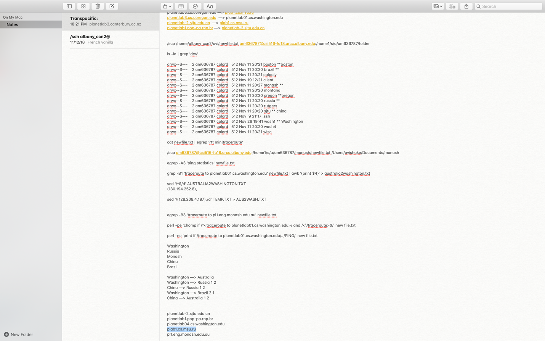

Transpacific:

[planetlab3.canterbury.ac.nz](http://planetlab3.canterbury.ac.nz)

[planetlab-2.cs.auckland.ac.nz](http://planetlab-2.cs.auckland.ac.nz)

[planetlab1.otemachi.wide.ad.jp](http://planetlab1.otemachi.wide.ad.jp)

[planetlab1.dojima.wide.ad.jp](https://www.planet-lab.org/db/nodes/node.php?id=10598)

Transatlantic:

[cse-white.cse.chalmers.se](http://cse-white.cse.chalmers.se)

[cse-white.cse.chalmers.se](http://cse-white.cse.chalmers.se)

[pl2.prakinf.tu-ilmenau.de](http://pl2.prakinf.tu-ilmenau.de)

[aladdin.planetlab.extranet.uni-passau.de](http://aladdin.planetlab.extranet.uni-passau.de)

puri.mimuw.edu.pl

Installation on System:

Anaconda

Base

Python 3.7

Xcode select

/ssh [am636787@csi516-fa18.arcc.albany.edu](mailto:am636787@csi516-fa18.arcc.albany.edu)

/scp /Users/ovishake/Documents/Programming/daemon.sh [am636787@csi516-fa18.arcc.albany.edu](mailto:am636787@csi516-fa18.arcc.albany.edu):/home1/s/a/am636787

/scp /Users/ovishake/Documents/Programming/servername.txt [am636787@csi516-fa18.arcc.albany.edu](mailto:am636787@csi516-fa18.arcc.albany.edu):/home1/s/a/am636787

Scp /Users/ovishake/Documents/Programming/ping_server.py [am636787@csi516-fa18.arcc.albany.edu](mailto:am636787@csi516-fa18.arcc.albany.edu):/home1/s/a/am636787

/scp /Users/ovishake/Documents/Programming/newfile.txt [am636787@csi516-fa18.arcc.albany.edu](mailto:am636787@csi516-fa18.arcc.albany.edu):/home1/s/a/am636787

date '+%A %W %Y %X'

planetlab01.cs.washington.edu —> [pl1.eng.monash.edu.au](http://pl1.eng.monash.edu.au)

planetlab3.cs.uoregon.edu —> [plab1.cs.msu.ru](http://plab1.cs.msu.ru)

[planetlab3.cs.uoregon.edu](http://planetlab3.cs.uoregon.edu) —> planetlab01.cs.washington.edu

[planetlab-2.sjtu.edu.cn](http://planetlab-2.sjtu.edu.cn) —> [plab1.cs.msu.ru](http://plab1.cs.msu.ru)

[planetlab1.pop-pa.rnp.br](http://planetlab1.pop-pa.rnp.br) —> [planetlab-2.sjtu.edu.cn](http://planetlab-2.sjtu.edu.cn)

/scp /home/albany_ccn2/ovi/newfile.txt [am636787@csi516-fa18.arcc.albany.edu](mailto:am636787@csi516-fa18.arcc.albany.edu):/home1/s/a/am636787/folder

ls -la | grep 'drw'

drwx--S--- 2 am636787 colord 512 Nov 11 20:21 boston **boston

drwx--S--- 2 am636787 colord 512 Nov 11 20:20 brazil **

drwx--S--- 2 am636787 colord 512 Nov 11 20:21 calpoly

drwx--S--- 2 am636787 colord 512 Nov 19 12:21 client

drwx--S--- 2 am636787 colord 512 Nov 11 20:27 monash **

drwx--S--- 2 am636787 colord 512 Nov 11 20:20 montana

drwx--S--- 2 am636787 colord 512 Nov 11 20:20 oregon **oregon

drwx--S--- 2 am636787 colord 512 Nov 11 20:20 russia **

drwx--S--- 2 am636787 colord 512 Nov 11 20:20 rutgers

drwx--S--- 2 am636787 colord 512 Nov 11 20:20 sjtu ** china

drwx--S--- 2 am636787 colord 512 Nov 9 21:17 .ssh

drwx--S--- 2 am636787 colord 512 Nov 26 19:41 wash1 ** Washington

drwx--S--- 2 am636787 colord 512 Nov 11 20:20 wash4

drwx--S--- 2 am636787 colord 512 Nov 11 20:21 wisc

cat newfile.txt | egrep 'rtt min|traceroute'

/scp [am636787@csi516-fa18.arcc.albany.edu](mailto:am636787@csi516-fa18.arcc.albany.edu):/home1/s/a/am636787/monash/newfile.txt /Users/ovishake/Documents/monash

egrep -A3 'ping statistics' newfile.txt

grep -B1 'traceroute to planetlab01.cs.washington.edu’ newfile.txt | awk '{print $4}' > australia2washington.txt

sed '/^$/d' AUSTRALIA2WASHINGTON.TXT

(130.194.252.8),

sed '/(128.208.4.197),/d' TEMP.TXT > AUS2WASH.TXT

egrep -B3 'traceroute to pl1.eng.monash.edu.au' newfile.txt

perl -pe 'chomp if /^<traceroute to planetlab01.cs.washington.edu>/ and /<\/traceroute>$/' new file.txt

perl -ne 'print if /traceroute to planetlab01.cs.washington.edu/../PING/' new file.txt

Washington

Russia

Monash

China

Brazil

Washington —> Australia

Washington —> Russia 1 2

China —> Russia 1 2

Washington —> Brazil 2 1

China —> Australia 1 2

planetlab-2.sjtu.edu.cn

planetlab1.pop-pa.rnp.br

planetlab04.cs.washington.edu

plab1.cs.msu.ru

pl1.eng.monash.edu.au

perl -ne 'print if /traceroute to [planetlab3.cs.uoregon.edu](http://planetlab3.cs.uoregon.edu)/../PING/' newfile.txt

perl -ne 'print if /traceroute to planetlab04.cs.washington.edu/../PING/' newfile.txt

awk ‘!/traceroute/{count++}/traceroute/{print count; count = 0}' file

sed '/PING/d'